1. **HostGator is responding very slow**. With 10-12 Users at one point of time the Server is not responding.
2. **G-Suite** – Pls attach G-Suite to mail id : [support@nibmt.org](mailto:support@nibmt.org)
3. Put the **Govt Approved Logo** with TM sign on the Homepage (mailed by Arpit)
4. On Homepage, many URL’s are not working fine

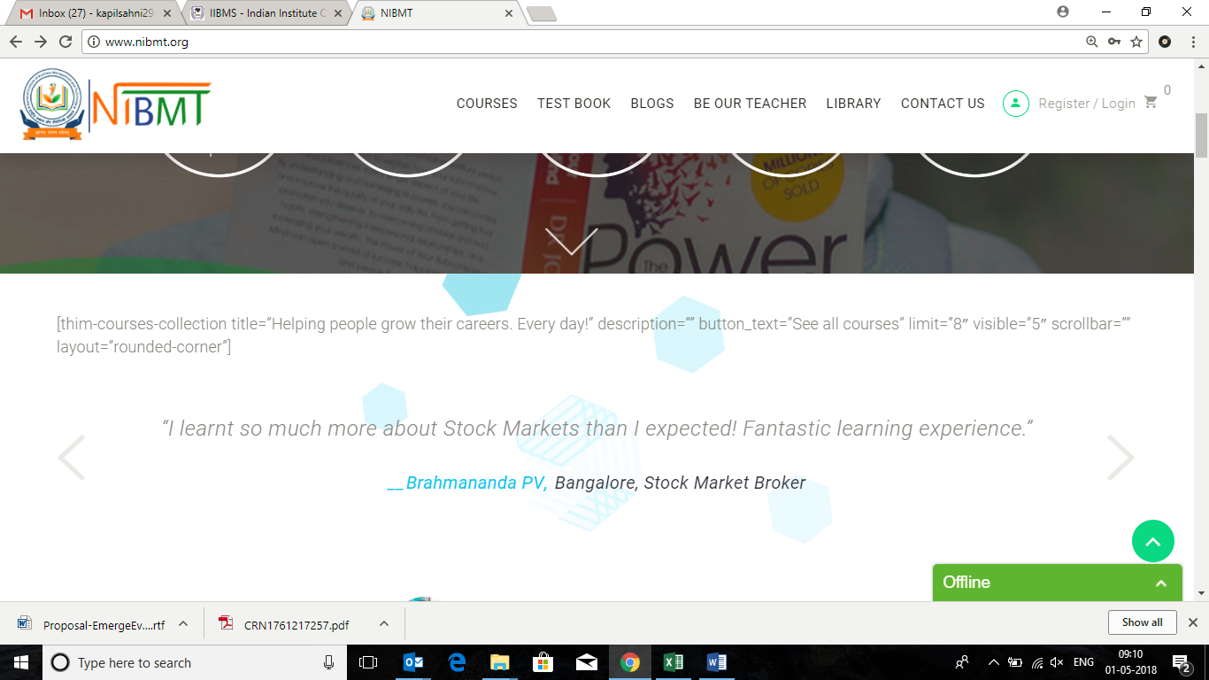

1. **SSL Certification** – Pls put the SSL of Hostgator offered with the Package
2. **Google Analytics** – Pls Join Google Analytics to URL [www.nibmt.org](http://www.nibmt.org)
3. **Library Page is Not Working completely**. Library Page should have a form which will capture all the details of the person downloading e-books.
4. **Be Our Teacher Page –** 
   * Count is not coming properly
   * Register Form on this page is not coming properly
5. **From Footer**– Pls remove below:

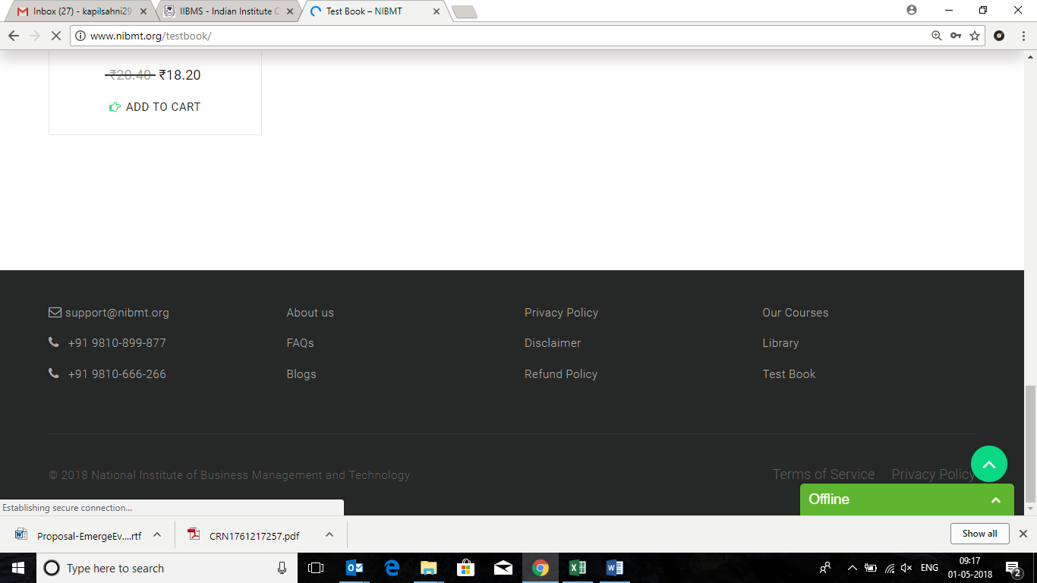

**My Profile**

* Phone Number and Avatar to be removed

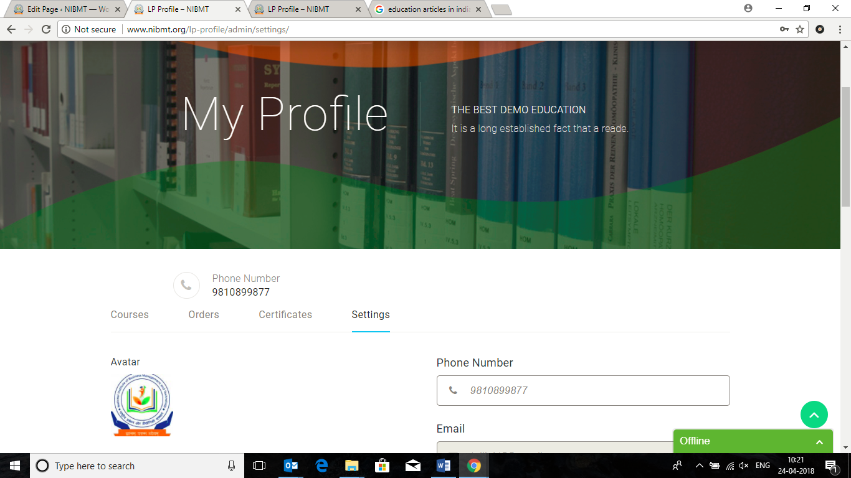

* Change Password option not working in **My profile** section

**>>TALIB**

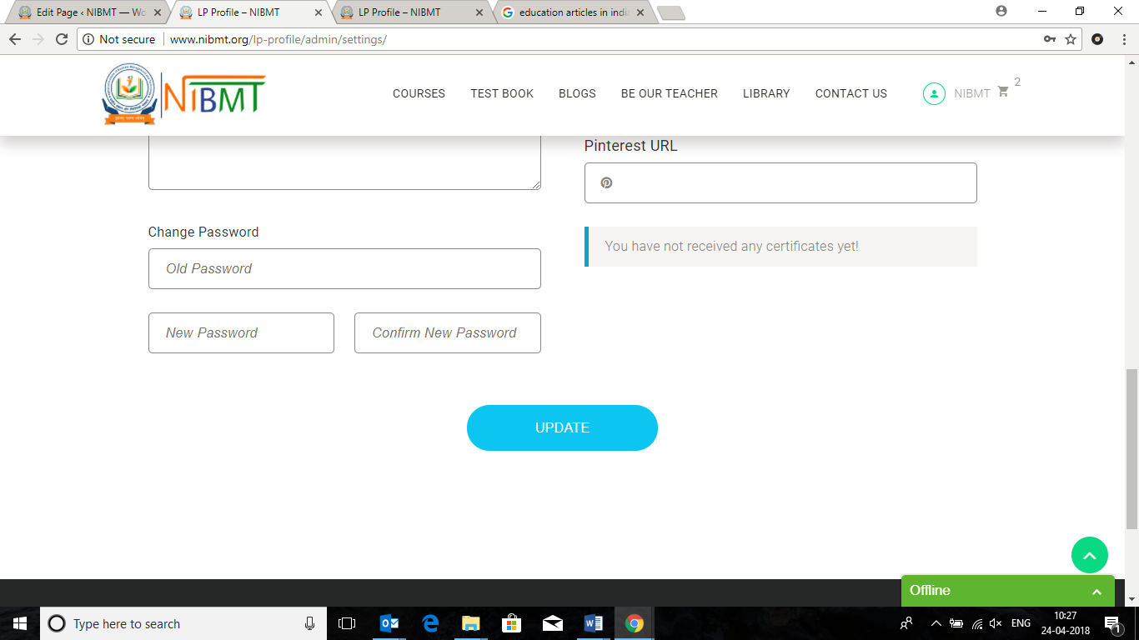

**Courses**

* Remove the Related Courses section from here

**>>TALIB**

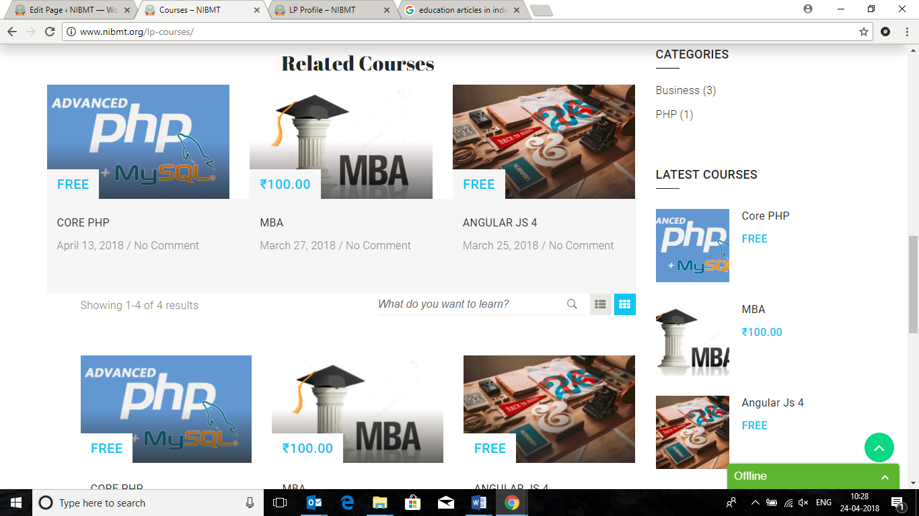

* Activate the Review section - ***** for all the courses

**>>TALIB**

**Blogs**

* Search Functionality & Grid/ List View to work in the Blogs section
* How to make changes in the Categories – Blogs?
* Like we want to change the Image etc…
  + Blogs -> Education (Category)

**>> ALL POINTS TALIB**

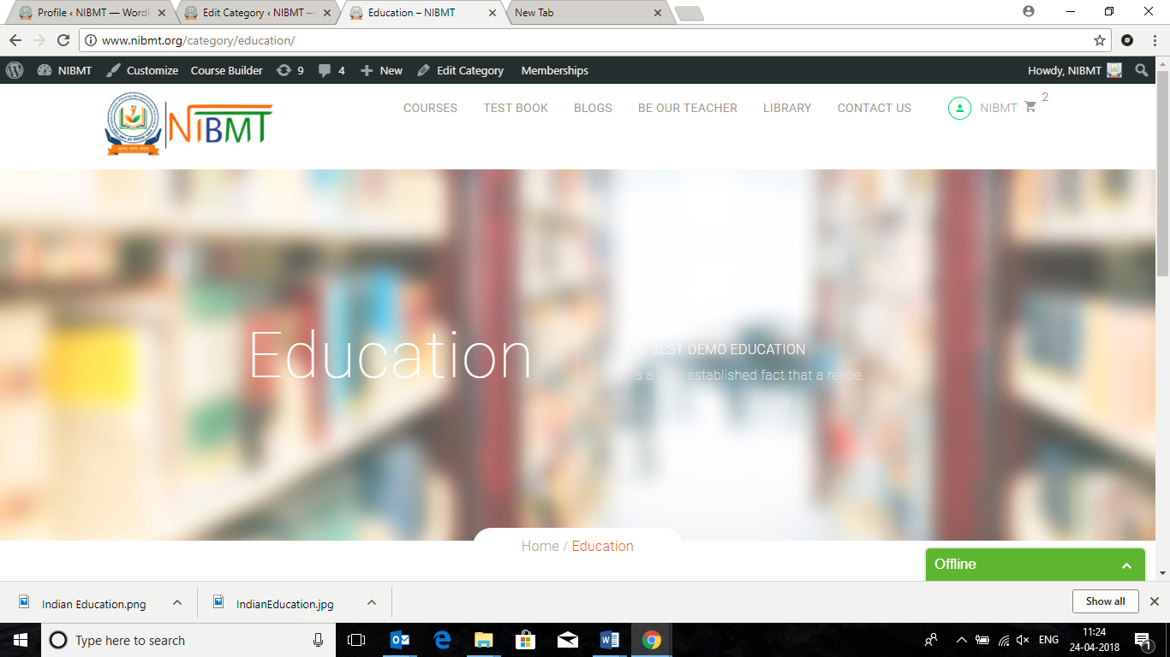

* How to change the Banner of Tags in Blogs ?

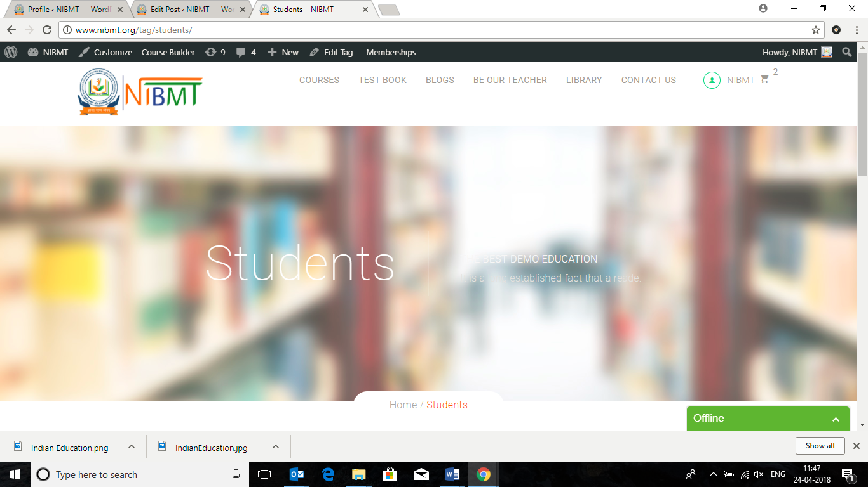

**Library**

* Search Functionality & Grid/ List View to work in the Blogs section

>>TALIB --> DONE

* Change USD to ₹ --> Done

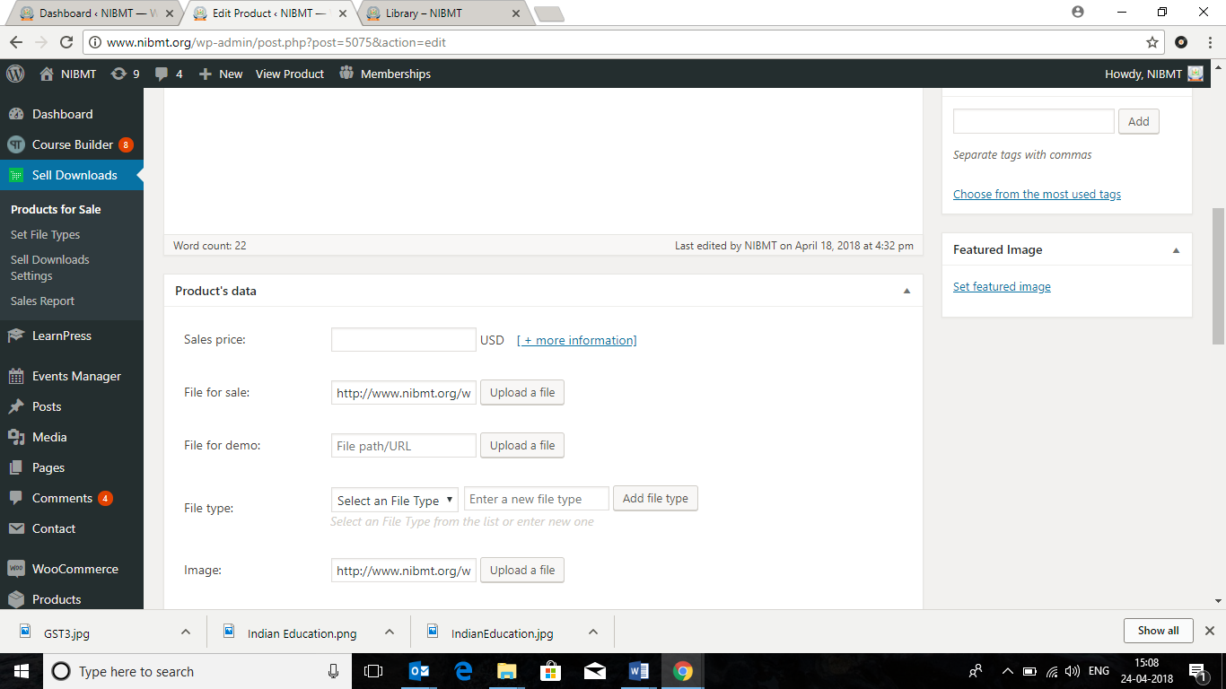

* Pls de-activate this Description Page, it is not required. --> Done
* Remove the Permalink from all Library section layout

**>>TALIB --> Done**

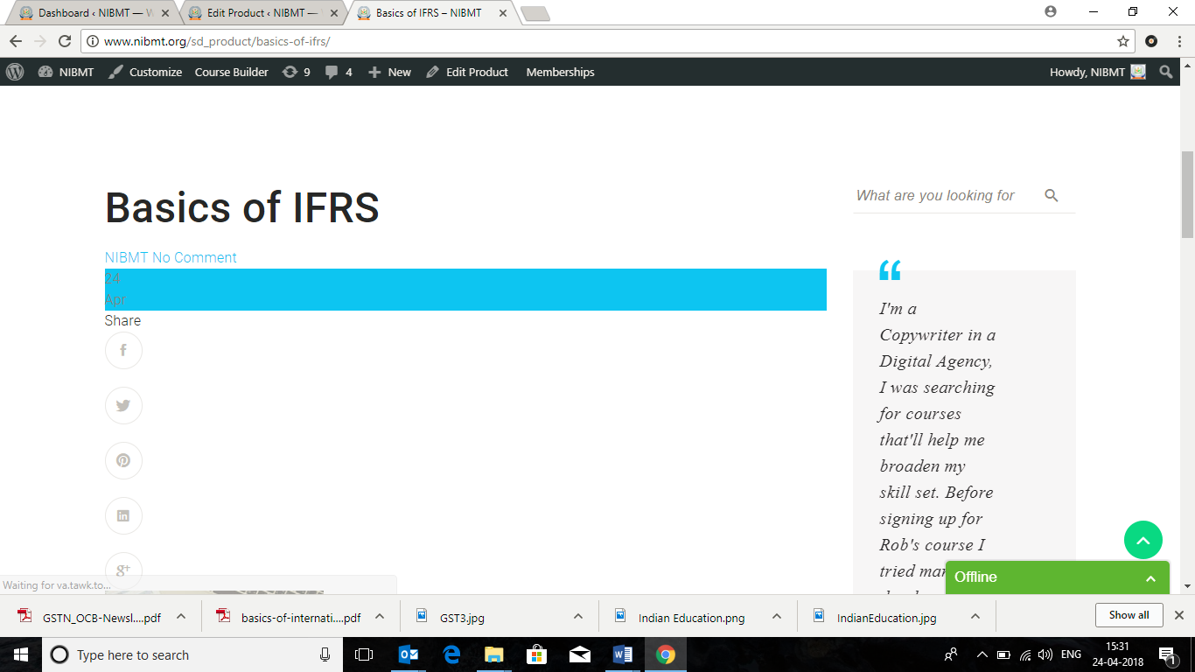

* ***Any Person who download the e-book needs to fill up below FORM - field’s.***
  + Name,
  + Mobile
  + EMail.
* This Form Database is not visible in the Admin Panel. Database has to come in the Admin Panel.
* Instead of **PAY** we need to write **SUBMIT**

**>> ALL POINTS TALIB**

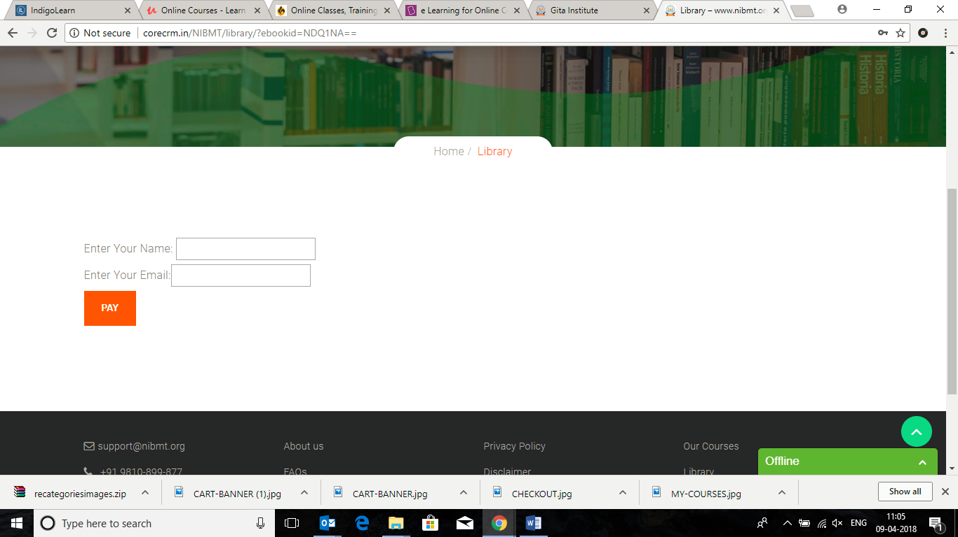

**On the HOME PAGE**

* Where is this page coming from? --> LearnPress-->Collections
* Need to change the url of SEE ALL COURSES

>> TALIB --> Have Query Against??



**Put the link -** [**http://www.nibmt.org/lp-courses/**](http://www.nibmt.org/lp-courses/)

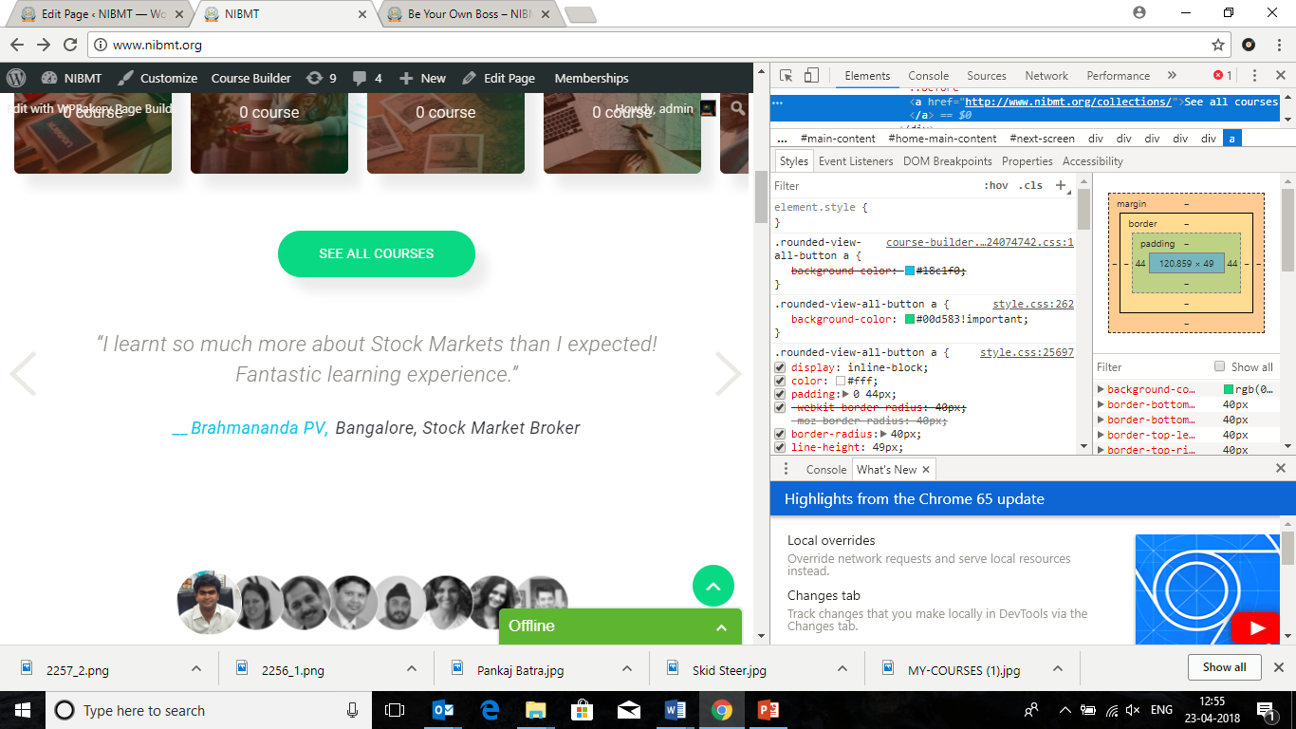

**On the Be Our Teacher Page**

* Steps are not navigating/ moving

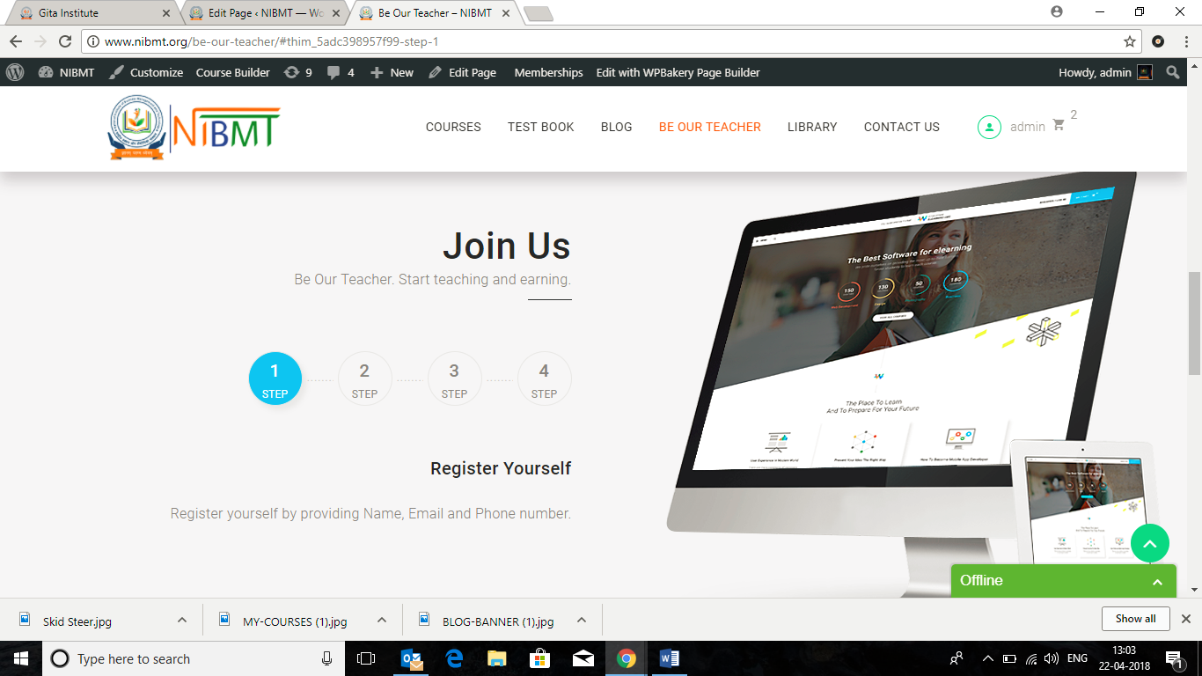

* Why is it saying that Please login to fill this form. This should work without Logging In.

>>TALIB

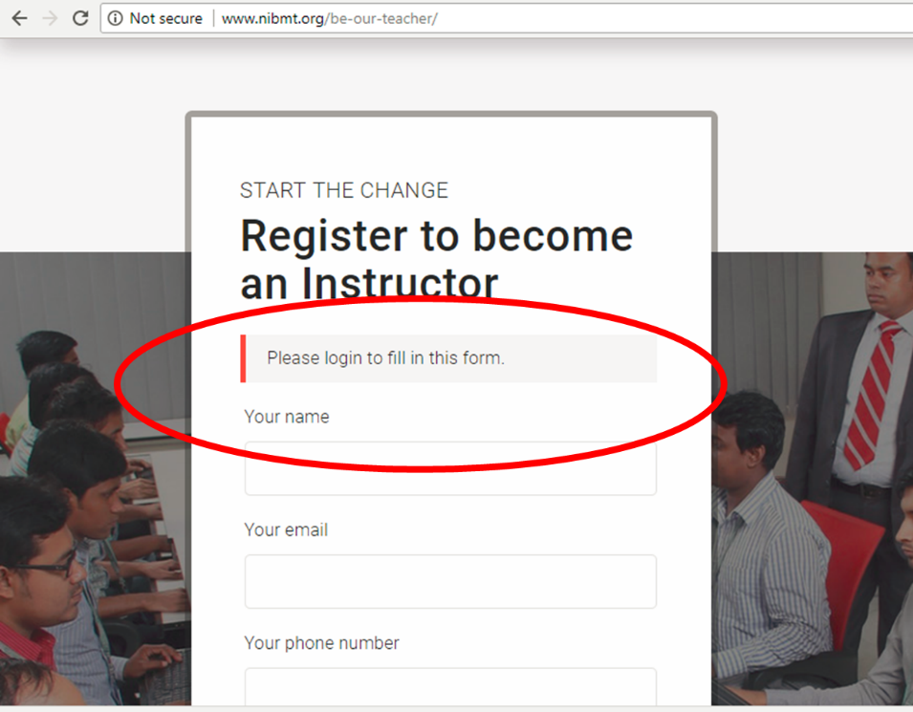

**On the My Profile Page**

Pls re-name the sections as:

* 1. **My Courses**
  2. **My Orders**
  3. **My Certificates**
  4. **My Profile**

**>>TALIB**

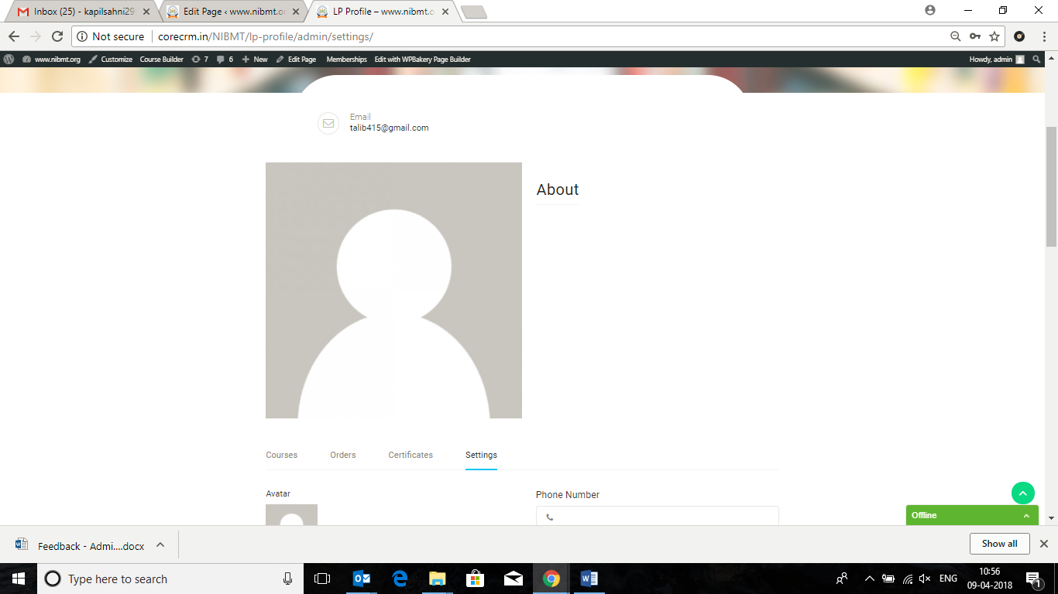

***In the User Registration Page***

***Please make the below change in the HEADLINE.***

***>> TALIB***

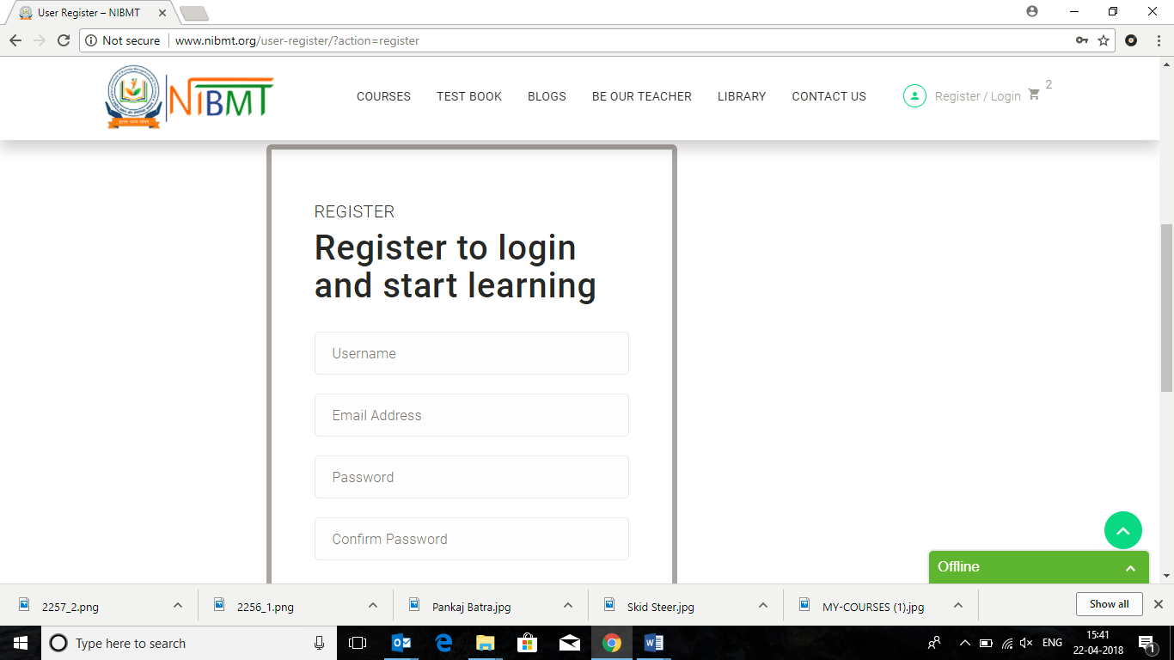

* Remove

Want to be an Instructor

Functionality in the bottom

**Register to**

**India’s best certified courses**

**Upcoming Events**

* Remove this Image from the Navigated Page

**>>TALIB**

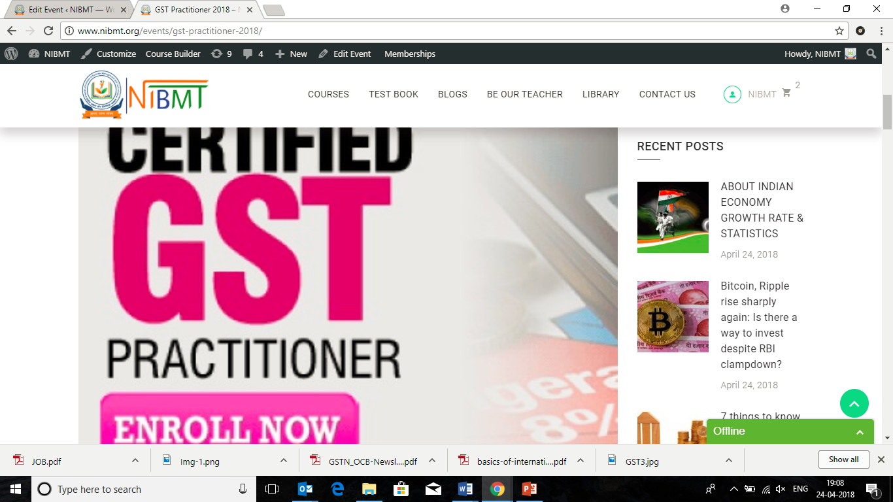

**Test Book**

* Unable to download any Test Series file even after making all the Payment
* Pls correct this

**>> TALIB**

